**Login to AWS Console and Launch EC2 server and follow the below steps**

1 . Choosing AMI ( Ubuntu Server 16.04 ) ami-2a7d5c0

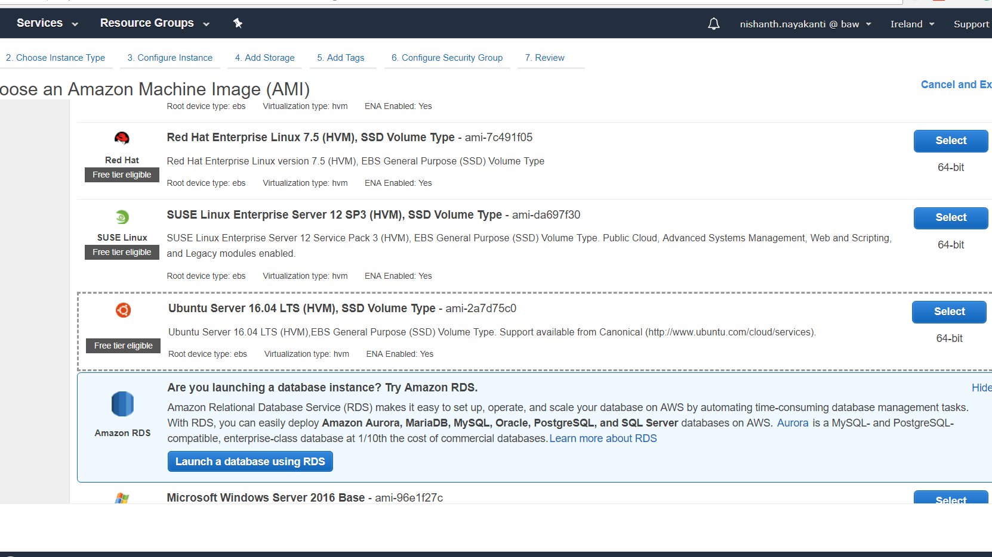

2. Choosing Instance type – t2.small

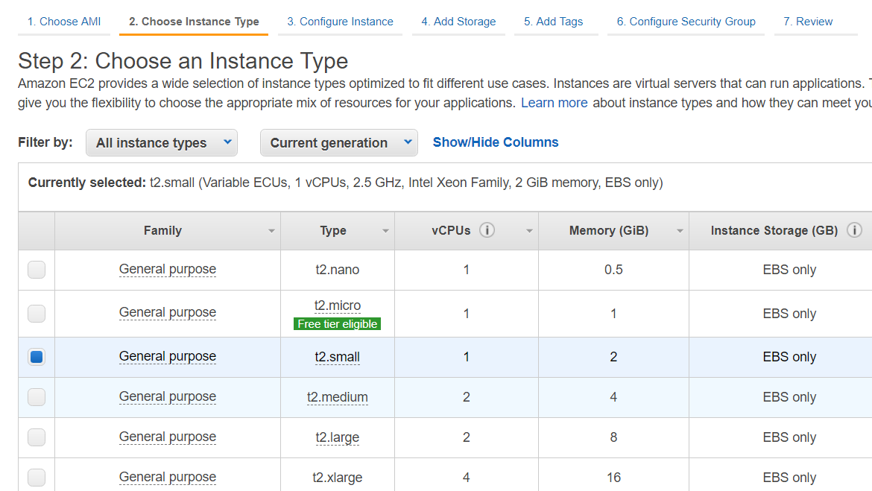

3. Configure_instance – network

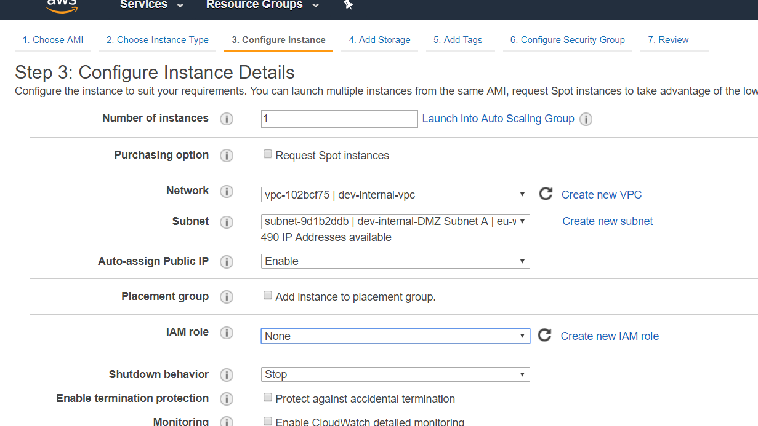

4. add storage – 20 gb

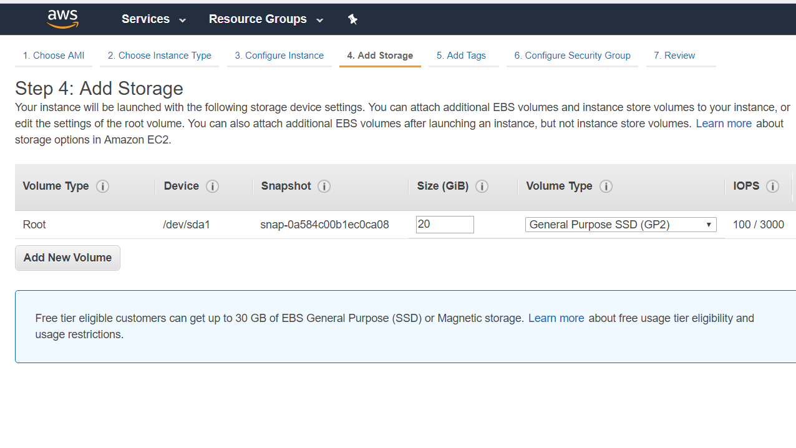

5. add tags

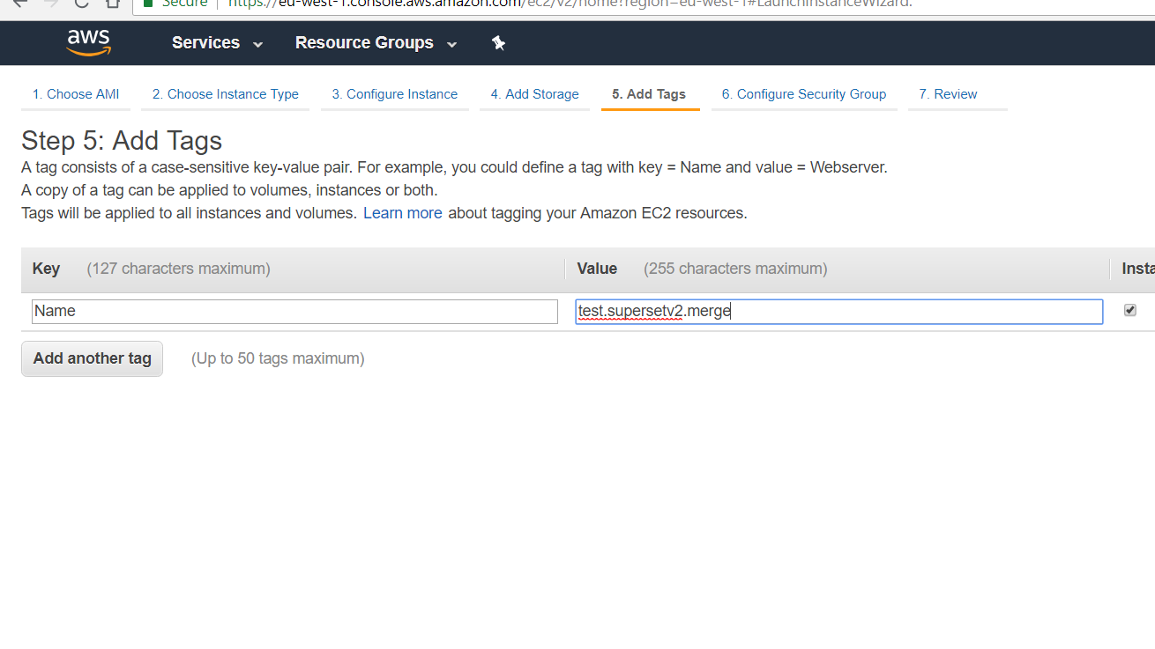

6. security_ groups – 1. Ba.external.ip and 2. ba.default

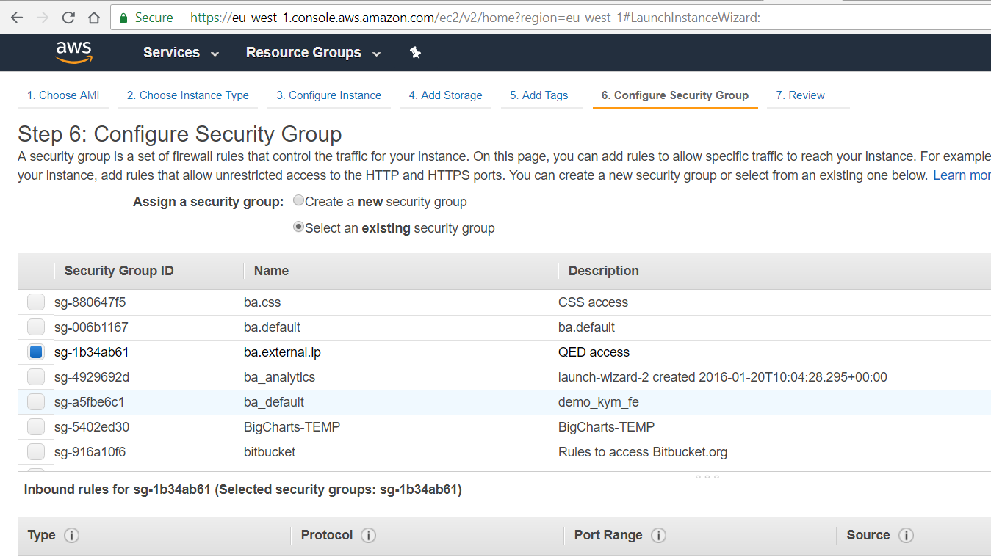

7. select keypair : dev-internal

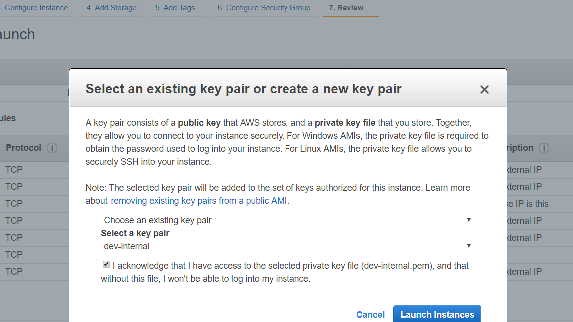

8. inbound rules

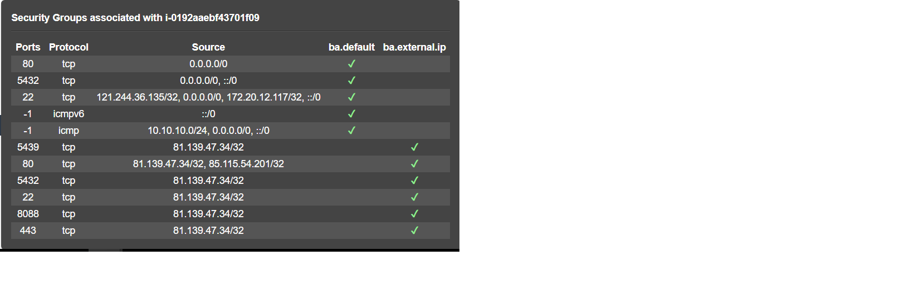

**Deploying superset qei on the server**

**#install python**

sudo apt update

sudo apt upgrade

sudo apt install python2.7 python-pip

sudo apt install python-pip

sudo apt install virtualenv

pip install virtualenv

**#install os dependencies**

sudo apt-get install build-essential libssl-dev libffi-dev python-dev python-pip libsasl2-dev libldap2-dev

sudo apt-get install build-essential libssl-dev libffi-dev python3.5-dev python-pip libsasl2-dev libldap2-dev

sudo apt-get install redis-server nginx

**#install latest node**

sudo apt-get install curl python-software-properties

curl -sL https://deb.nodesource.com/setup_10.x | sudo -E bash -

sudo apt-get install -y node.js ( for ubuntu 16.4)

sudo apt-get install -y nodejs ( for ubuntu 18>)

sudo npm install -g yarn

**#Clone latest superset_v2 merge from qed repository**

git clone https://suraj_raghupathi@bitbucket.org/beyondanalysis/superset_qei.git qei

**#virtualenv**

virtualenv superset_v2

source superset_v2/bin/activate

cd qei

**# install for development**

pip install -r requirements.txt

pip install -e .

pip install psycopg2

pip install redis [not required]

pip install sqlalchemy-redshift [not required]

pip install click==6.7

**#needed to initialize a new metadata DB**

**#create an admin user – give username, password, email as per the prompt**

fabmanager create-admin --app superset

**#initialize the database**

superset db upgrade 1a1d627ebd8e

superset db upgrade g6a068a31f18

**# Create default roles and permissions**

superset init

**# Load some data to play with (Please ignore on production)**

superset load_examples

**#compile front end node modules**

cd superset/assets/

sudo yarn

sudo npm run dev

**#Start the application**

**#start the redis server**

Tmux new –s redis

redis-server

**#tmux**

Tmux new –s superset

**#start the app**

superset runserver –d

**#Nginx setup with SSL**

**#Add SSL certificates**

* Create a folder ssl inside /etc/nginx

      cd  /etc/nginx

sudo  mkdir ssl

* Place SSL certificate file(**baworks.beyondanalysis.net.crt**), key file (**baworks.beyondanalysis.net.key**) and pem file (**dhparam.pem**) inside the ssl folder created
* Create a folder config inside /etc/nginx

cd  /etc/nginx

 sudo  mkdir config

* Copy **ssl.conf** into config

**#Change the nginx.conf**

**Replace the nginx.conf**

* Make sure that there are no syntax errors in files by executing following command.

sudo nginx –t

**#Restart the nginx**

sudo service nginx restart